# **QUESTION 1**

Dashboard showing the Sale Trends by Time and Region with categories, top selling products

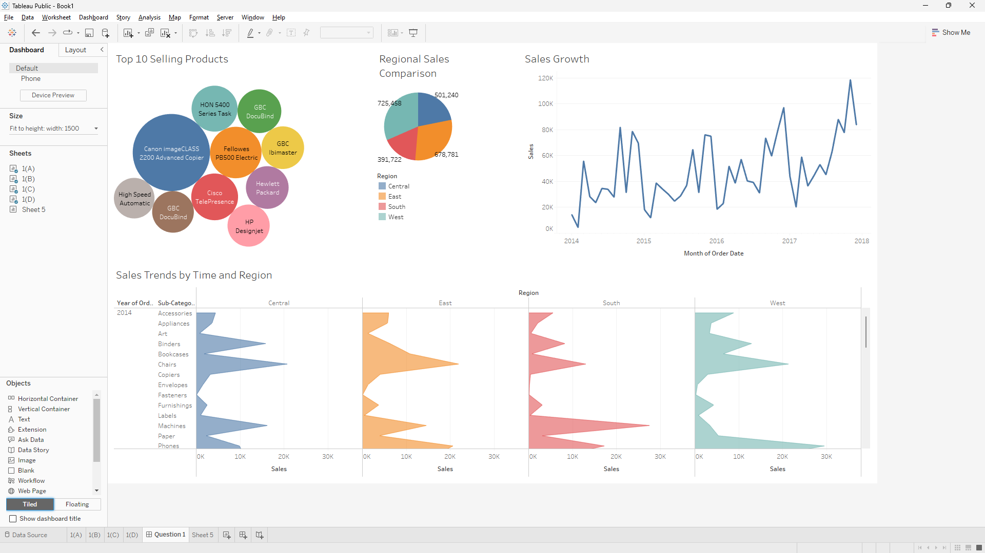

# **Question 2**

Dashboard showing clustering of people based on segments, clustering of nations using parameters like profit, sales, etc.

